**Software Engineering Project**

**Residency Assignment 1**

Salmanuddin Rehan Mohammed

CS 630 Software Engineering

Jason Turner

May 29, 2025

**Software Engineering Project**

**Problem Statement**

Users often forget important tasks, events, and meetings. Missed appointments, forgotten and delayed tasks can lead to loss in productivity, reduced efficiency, and poor time management. A simple reminder app can help the user to schedule reminders at specific times. While calendar apps can do this task, they lack timely notification that can prompt the user to take timely action.

**Solution Overview**

This lightweight web application aims to allow users to schedule reminders sent via SMS. It helps in reducing missed tasks. In addition, it will help in improving time management and increase efficiency. This tool can be beneficial to busy individuals and remote teams.

**Key User Stories**

1. As a user, I want to schedule a reminder message with a specific time and recipient so that it is sent automatically.
2. As a user, I want to receive confirmation that my reminder was sent successfully.
3. As a user, I want to view all the reminders so that I can keep a track of all my upcoming tasks and deadlines.

**Functional Requirements**

1. The user can enter a recipient, message, and select reminder type.
2. The system shall validate all the required fields before saving the reminder.
3. The system shall allow users to view a list of all their scheduled and sent reminders.
4. The system shall provide a dashboard to view all the upcoming reminders.

**Non-Functional Requirements**

1. Must respond to reminder requests within 10 seconds.
2. The system shall support 50 users concurrently.
3. The user interface should be accessible in web and mobile devices.

**Conceptual Wireframes**

Fig 1: Design for Scheduling Reminder

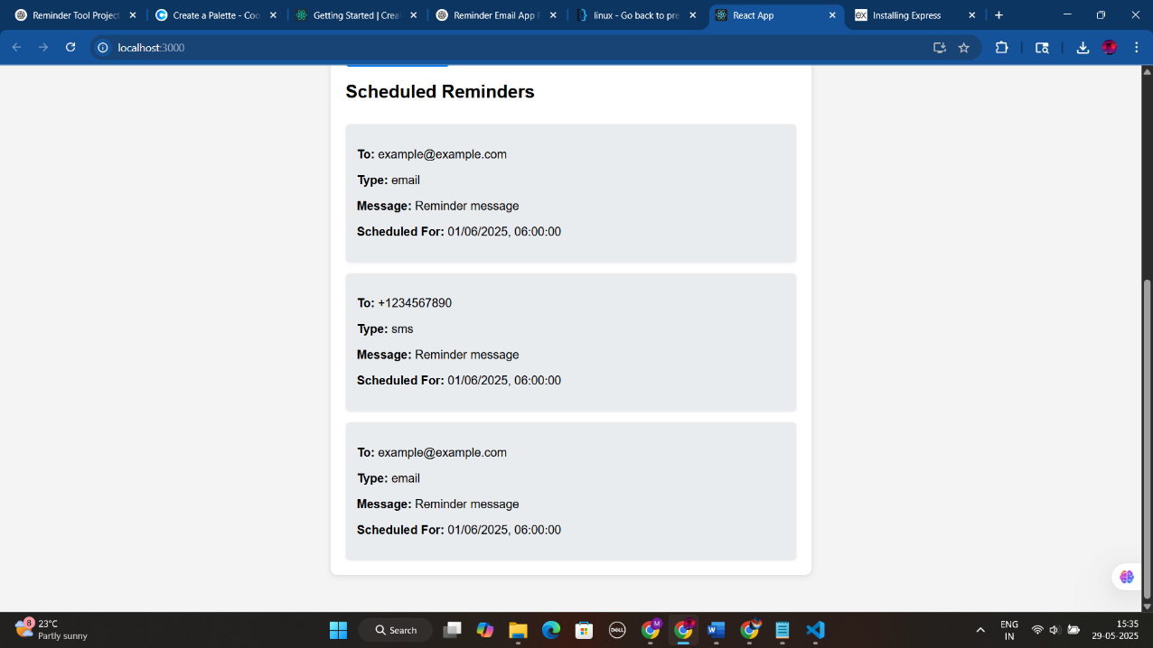

Fig 2: List of Scheduled Reminders

**High Level Architecture Diagram**

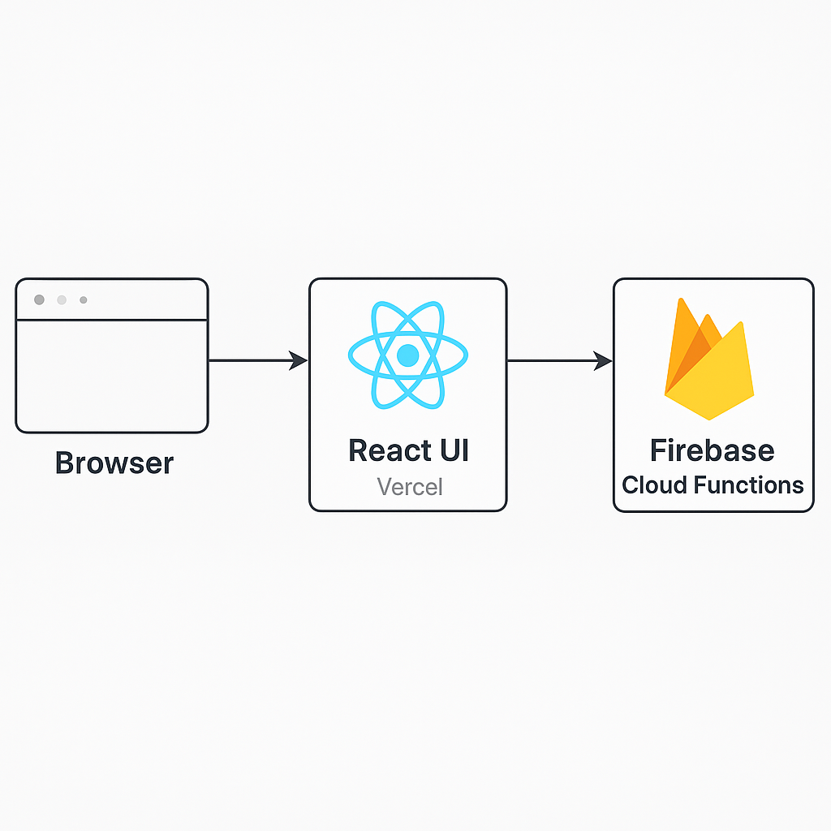

Fig 3: High Level Architecture Diagram

**Technology Stack Justification**

1. I am using React for front end development due to its simplicity and ease of use.
2. Firestore database: for storing the reminder list and displaying it in the dashboard.
3. I am using Firebase scheduled cloud functions to send emails at the desired date and time.
4. Firebase: It allows for automatic deployments using GitHub.
5. Jest: Testing framework as it has a good community support for any queries and questions that I may run into.

**Initial Working MVP**

Fig 3: Actual Working application with scheduling a reminder with a specific date and time

**Automated Tests**

**Test Case 1: Schedule Reminder Successfully**

Objective: To ensure that the valid reminder is successfully stored in the Firestore database.

Input:

* To: [test@example.com](mailto:test@example.com)
* Message: This is a test reminder
* Datetime: 2025-29-05

Steps:

1. User fills in all the fields.
2. User selects email.
3. Clicks “set reminder”.

Expected Result:

* Reminder appears in the dashboard.
* Firestore reminders collection contains the new document.

**Test Case 2: Input Validation (check empty fields)**

Objective: To ensure that the valid reminder is successfully stored in the Firestore database.

Input:

* To: “ ” (empty)
* Message: “This is a test reminder”
* Datetime: “2025-06-01T14:00”

Steps:

* Leave recipient field blank.
* Fill out other fields.
* Clicks “set reminder”.

Expected Result:

* Form should not submit.
* Error message appears: “please fill in all fields”.

**Test Case 3: Fetch and Display Reminders**

Objective: Ensure the dashboard correctly fetches and displays reminders.

Precondition:

* At least one reminder exists in the firestore database to display.

Steps:

* Open the application.
* Wait for useEffect to run fetchReminders.

Expected Result:

* Reminders are fetched from Firestore.
* They appear under the “Scheduled Reminders section” section with correct data.

**Developer Log**

* Today I focused on finalizing the project for this residency assignment.
* I focused on finalizing the technology stack and developing the initial working prototype of the project.
* I switched back and forth between choosing a full stack project versus building a project using the firebase cloud services.
* I finalized on using firebase due to limited time as choosing a full stack MERN technology would have created complexities in building the front end as well as the back end.
* Key challenges included integrating the front end and the back end.
* I decided to use Firebase deployment for easy deployment using GitHub.